# SERVER-SIDE INTERNET PROGRAMMING

# PROJECT REPORT



Group 6 :

|  |  |
| --- | --- |
| 1. Dede Dwi Arda Nugraha | 001202400188 |
| 2. Muhammad Faris Sakhi Ashari | 001202400057 |
| 3. Yoga Setyawan | 001202400197 |

**PRESIDENT UNIVERSITY**

Jababeka Education Park, Jl. Ki Hajar Dewantara, Kota Jababeka, Cikarang Baru,

Bekasi 17550 – Indonesia 2025

# Probability and Statistics Project Report

**Project Name: ArSaWan Library**

**Team Member:**

1. **Dede Dwi Arda Nugraha (001202400188)**
2. **Muhammad Faris Sakhi Ashari (001202400057)**
3. **Yoga Setyawan (001202400197) URL:**

**The App:**

<https://yogasetyawan06.github.io/GeniusGroup_SsipProject/>

**The Repo in GitHub:**

<https://github.com/YogaSetyawan06/GeniusGroup_SsipProject>

## Introduction

The ArSaWan Library is a book management system that allows users to manage books, authors, and publishers through a CRUD (Create, Read, Update, Delete) interface. The system provides structured tables, forms for data entry, and confirmation dialogs for critical actions.Technologies Used

## Features and Page Structure

* 1. **Home Page**

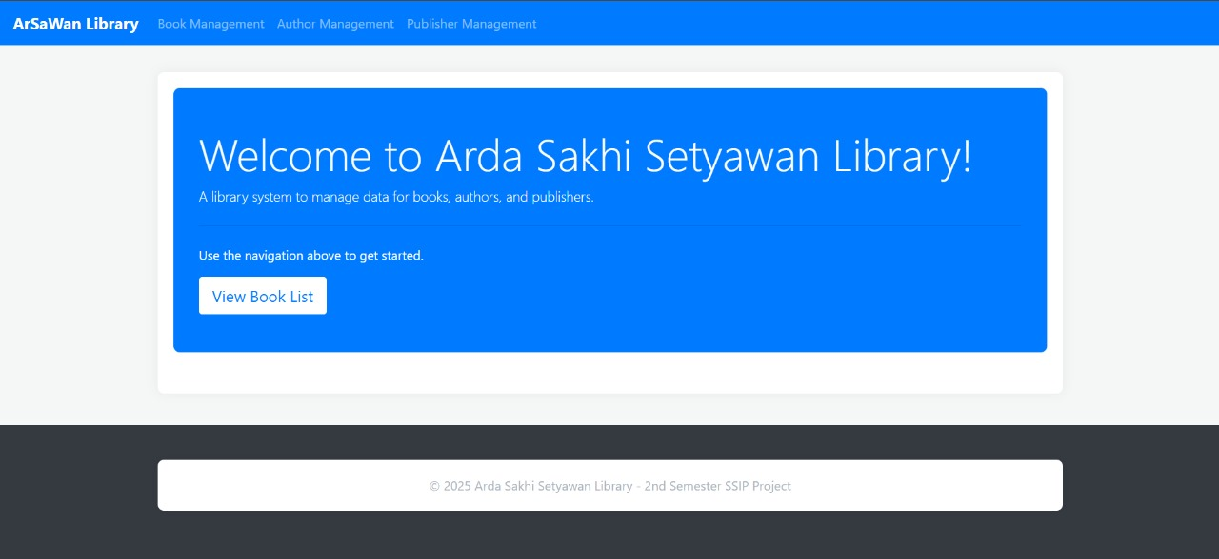

Displays a welcome message and a brief introduction. Provides navigation links to Book Management, Author Management, and Publisher Management

* 1. **Book Management**

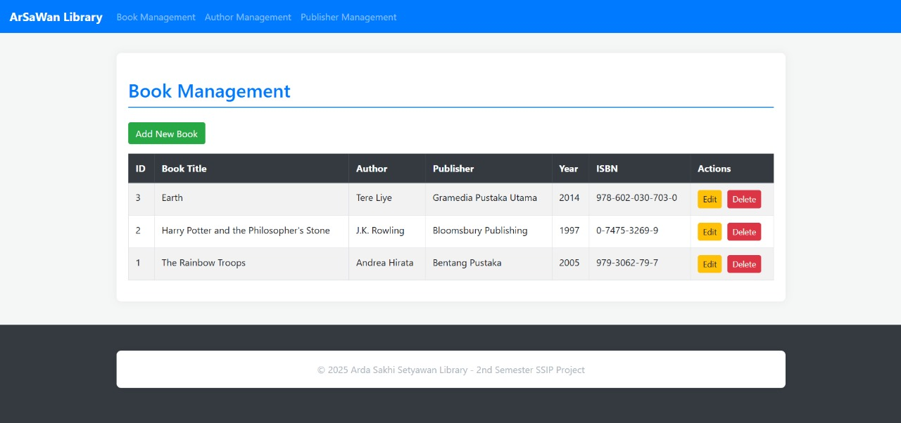

**Book Listing Table**

Displays books with columns:

* ID
* Title
* Author
* Publisher
* Year
* ISBN
* Actions

Actions:

* Edit
* Delete

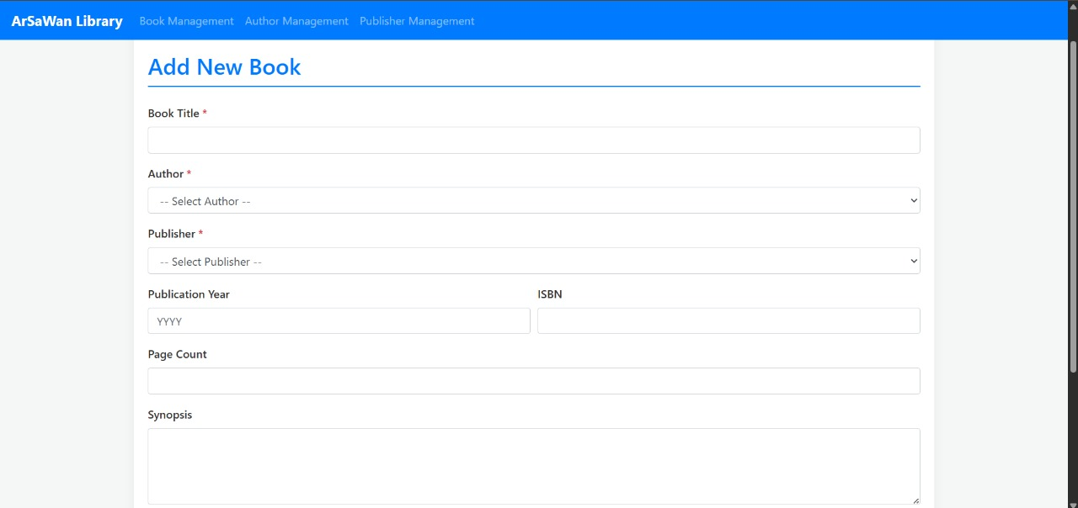

**Add New Book Form**

Fields:

* Book Title* (required)
* Author* (dropdown selection
* Publisher* (dropdown selection)
* Publication Year (YYYY format
* Page Count (optional)
* Synopsis (optional text area)

**Edit Book Form**

* Pre-filled with existing book data.
* Similar structure to the "Add New Book" form.

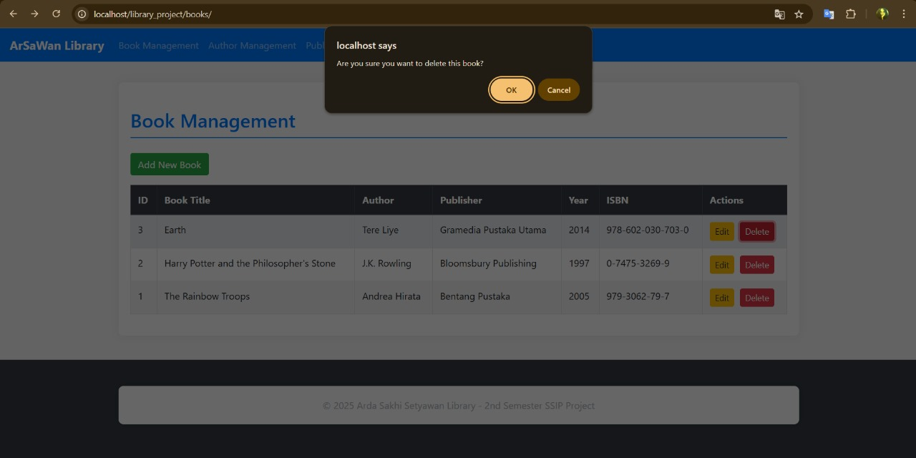

**Delete Confirmation**

* 1. **Author Management**

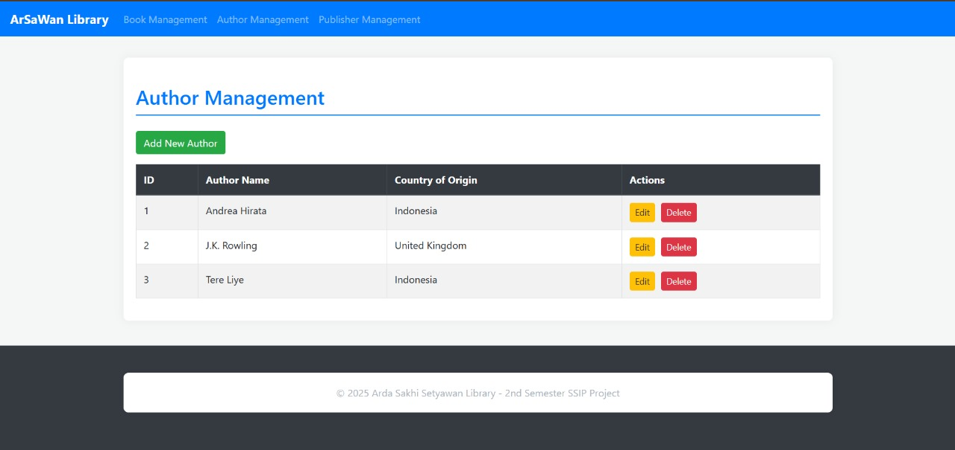

**Author Listing Table**

Columns: ID, Author Name, Country of Origin, Actions

Actions:

* Edit
* Delete

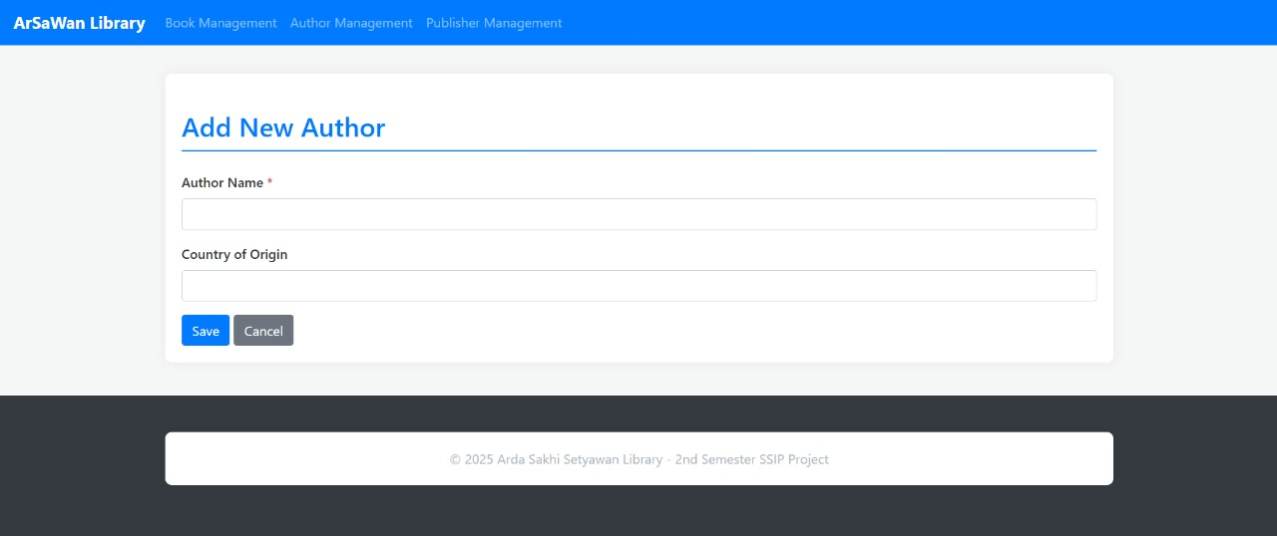

**Add New Author Form**

Fields : Author Name (Required), Country of Origin (Optional)

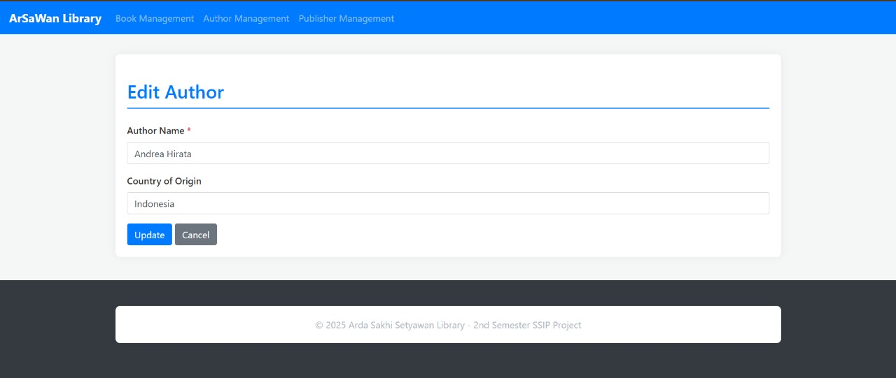

**Edit Author Form**

Pre-filled with existing author details.

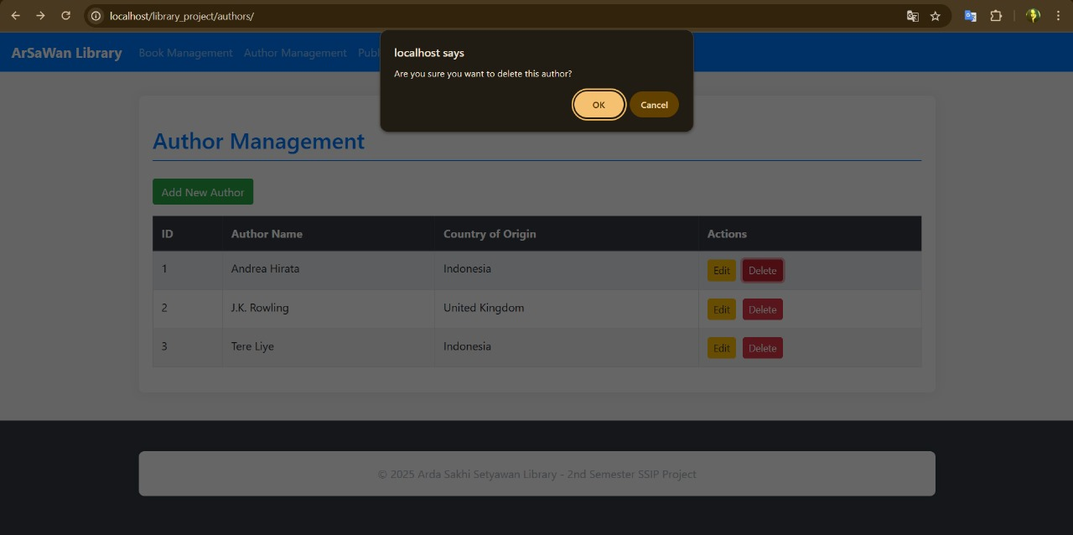

**Delete Confirmation**

* 1. **Publisher Management**

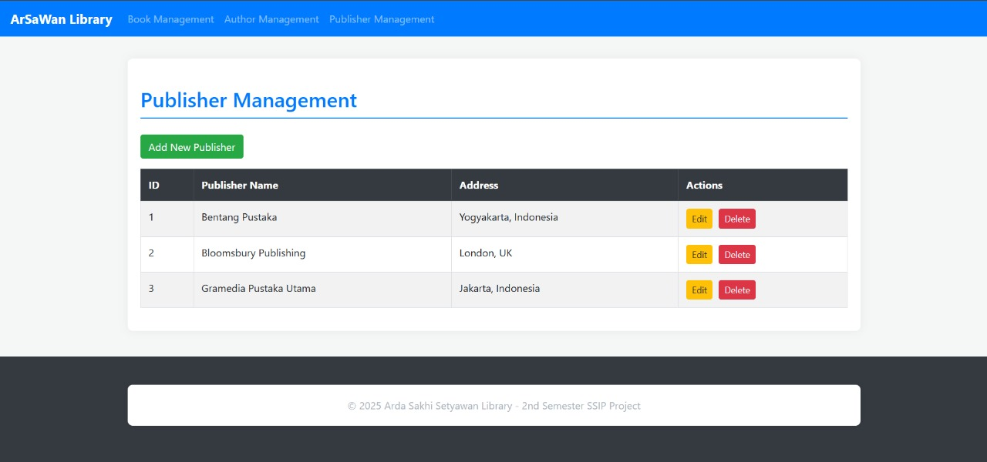

**Publisher Listing Table**

Columns: ID, Publisher Name, Address, Actions

Actions:

* Edit
* Delete

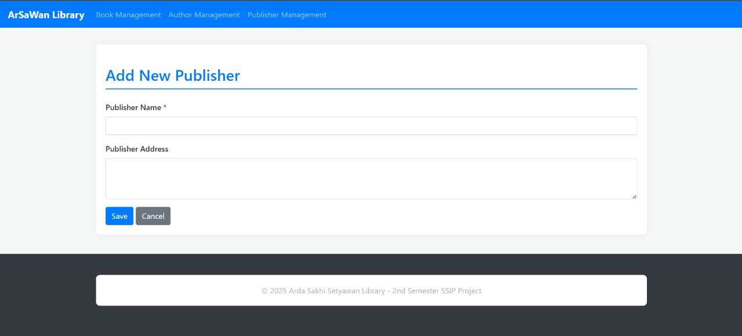

**Add New Publisher Form**

Fields:

* Publisher Name* (required)
* Publisher Address (optional)

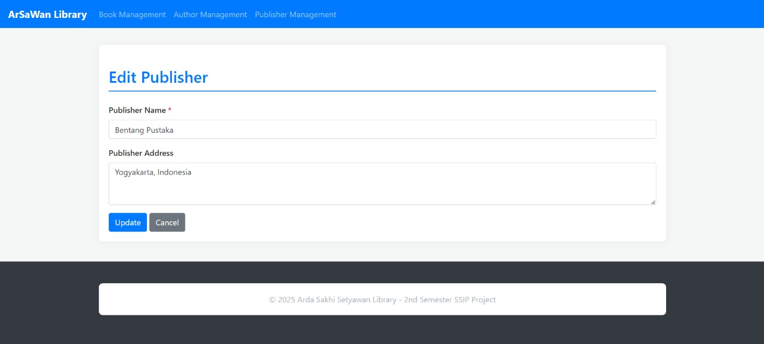

**Edit Publisher Form**

Pre-filled with existing publisher details.

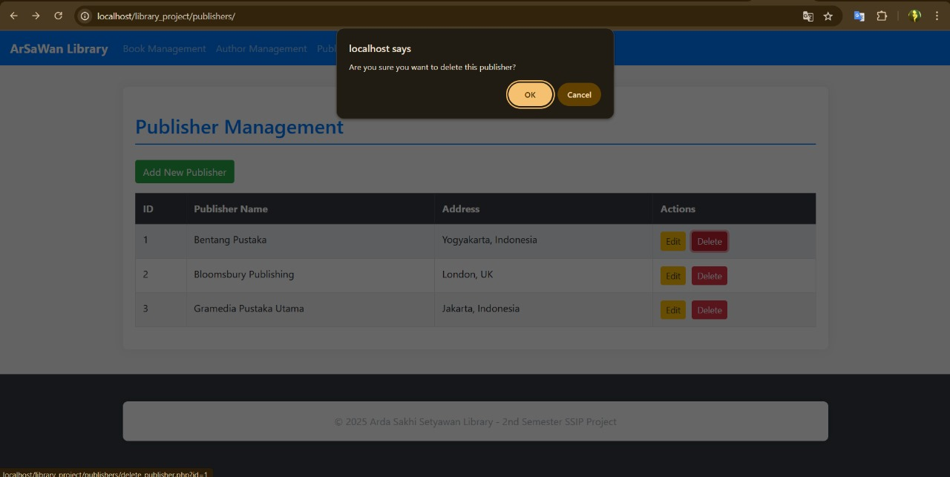

**Delete Confirmation**

## Database

ERD

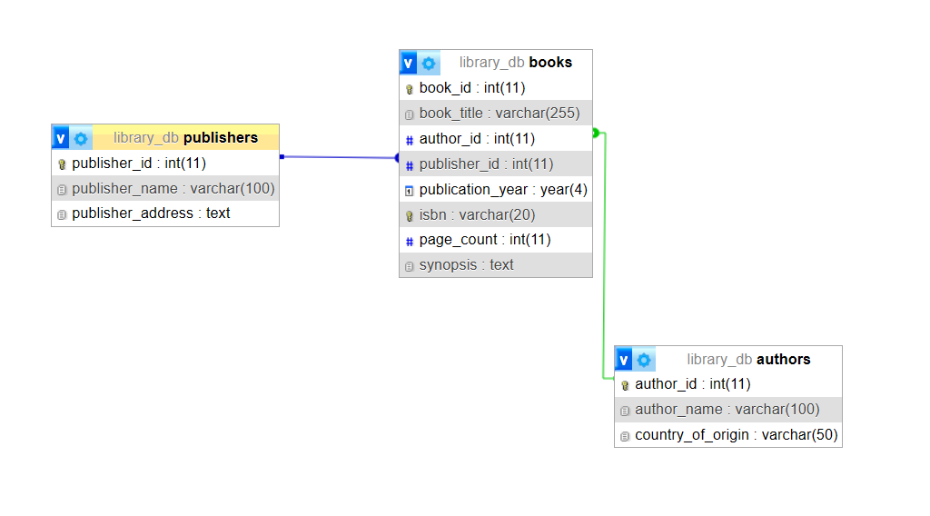

## CRUD Operation

Offers a complete set of CRUD (Create, Read, Update, Delete) features for efficient data management. For the Create (Add New) function, users can fill out dedicated forms to add new entries such as books, authors, and publishers. Each form is designed to be user-friendly, making it easy to input new data.  
 The Read (View Listings) feature displays the data in tables with built-in filtering options, allowing users to quickly find specific entries based on selected criteria.

When performing Update (Edit) actions, users are presented with pre-filled forms containing the existing data, making it convenient to modify information without re-entering everything from scratch.

Finally, the Delete function includes a confirmation dialog to prevent accidental removals, ensuring that users intentionally delete only the data they really want to remove.